Correlation Overview

As was outlined in several studies [16], [44], [45], [46], [47], and is visually shown in Figure 1, weather patterns play a critical role in the production of renewable energy generators. However, another key theme within the literature was investigating the probability of renewable droughts in one part of Australia affecting other NEM regions. To conduct high level research on the likelihood of weather droughts in the NEM using AEMO’s data the following investigation is presented.

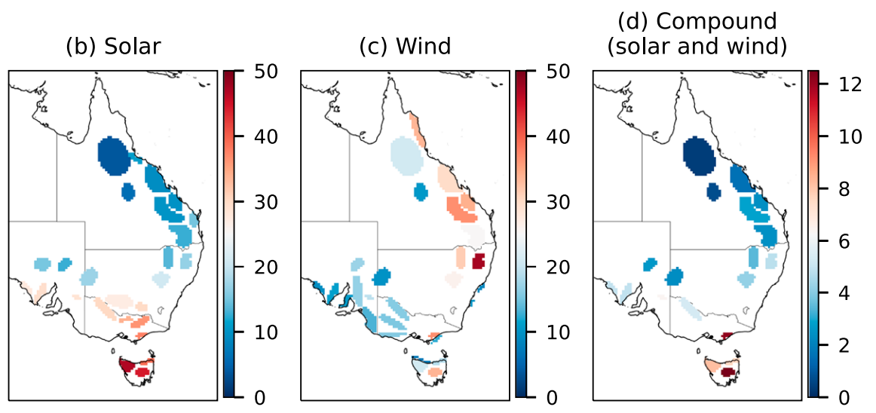

**Figure 1:** Findings of Richardson et al. on the probability of weather droughts occurring in different regions of the NEM [16].

To investigate the correlation between different REZ sites in SA, Victoria, and NSW, AEMO’s trace data can be used. As is discussed in the local data, there is a stretch from FY2030-31 to FY2042-43 where the rolling reference years vary from FY2010-11 to FY2022-23 and thus the correlation investigation will be restricted to these years. Also, since AEMO’s generation traces are between 0 and 1, there is no need to normalise the data in a pre-processing step.

To calculate the correlation between two time series data in Python, the Pandas function *corr()* can be used. The following script performs the following high-level operations: read in the trace data for each REZ, update the data frame format, remove years outside of the aforementioned range, add the trace data as a column to a data frame, calculate the correlation between each column. The last section of the script formats the heatmap plot.

One question that this analysis raises is whether there is any relationship between the geographically distance of REZs and their correlation. To answer this question, an additional analysis was performed. The first part of the analysis was to measure the distance between each REZ. This was achieved using AEMO’s GIS file for the REZ boundaries and measuring the distance between the approximate centres of each REZ. The measurements are visually shown in Figure 2 and numerically in the “Correlation and Distance” excel file. Note that an “*” marks a site that is forecasted to be developed over the forecast period.

**Figure 2:** Google Earth measurements of the distance between each South Australian, NSW, and Victorian REZ.